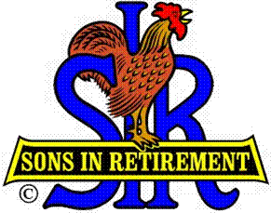
Las Trampas Branch 116
BEC Meeting Agenda
January 21, 2019, 9:30 AM
The Mission of SIR is to improve the lives of our members through fun activities and events – while making friends for life.

09:15 Coffee Available
09:30 Call to order; Secretary confirm a quorum; Welcome
09:31 Secretary – Fred Schafer – Approval of Nov 19 BEC minutes
09:33 Treasurer – Jim Nickels – Report; Review Budget
09:37 Committee Reports
- Attendance – Kevin Donahue – Attendance, Guests, Missed Lunch Letters
- Membership – Phil Goff – New Members to be inducted
- Spring Fling – Alan Fitzgerald – Date and Plans, Promotion
- Audit Report – Ron Armijo
- Nominating Committee – Marty Katz
09:47 Big SIR Report –Jerry Hicks
- Organization Chart; BEC carries out policy; Department Heads
- Committee Structure (Hand Out) – Assistants and identify your successor
- Goals for 2019 - Participation
- Luncheon schedule – first call, Timing, a little more time for conversation
10:00 Little SIR Report – Michael Barrington
1. Seating at Luncheons – 2 open seats at each and 1 open table
2. Speaker: Gabriel Szilardi
10:05 RAMP Department Head Introduction and Reports
10:09 Old Business
- Boundary Oak contract – Marty Katz
10:10 New Business:
- Approval of Activities for 2019 – Fred Wachowicz
- Ladies at Luncheon Discussion – Michael Barrington
10:15 Other Discussion
10:30 Dine-O-SIR Brunch, Crow Canyon, Sunday, Jan 29, 1030
Next BEC Meeting, Feb 18, 0930
Adjourn

